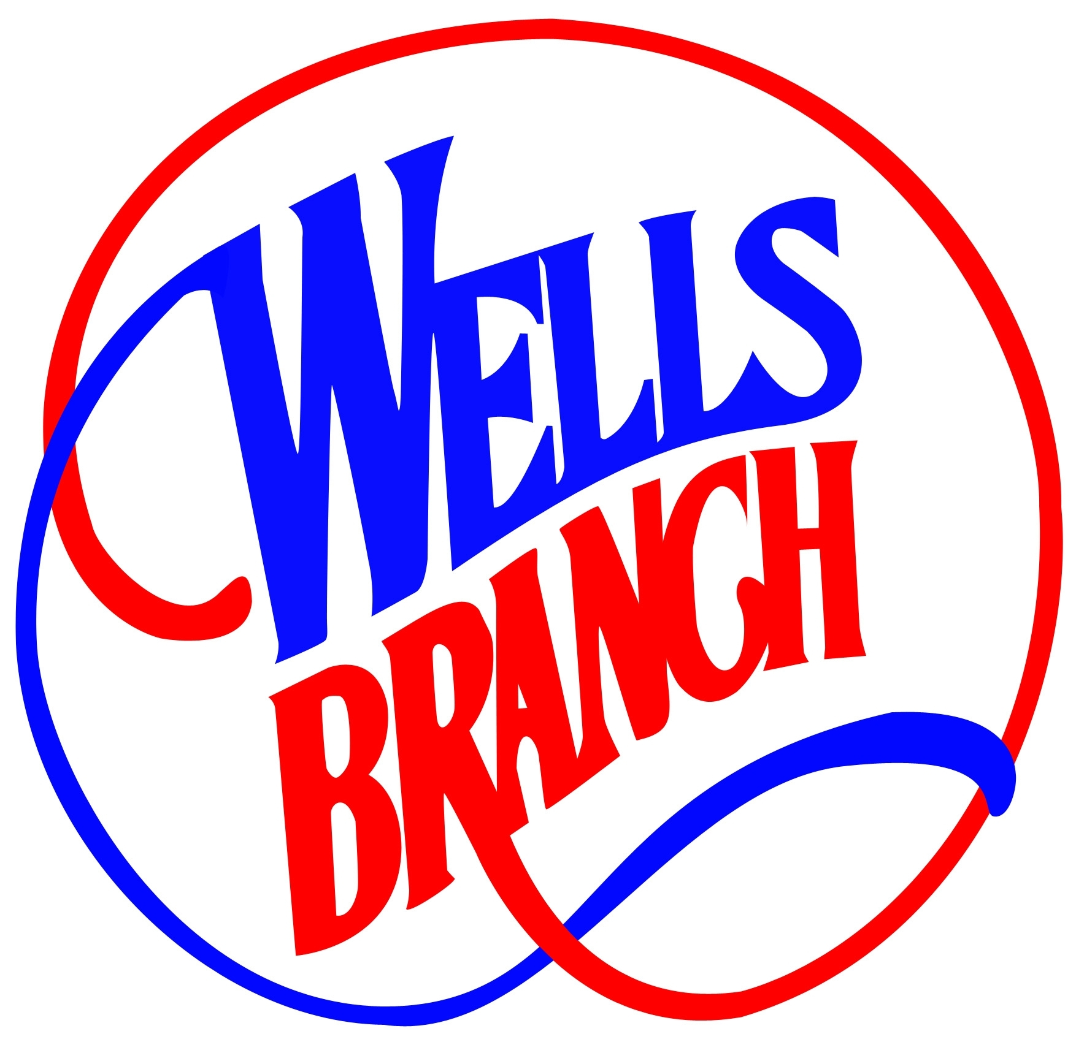
Wells Branch Starting New Single Stream Recycling Program
In partnership with
IESI TX CORPORATION
In partnership with
IESI TX CORPORATION
In partnership with
IESI TX CORPORATION
In partnership with
X CORPORATION
CLIP & SAVE INFO SHEET
The Wells Branch MUD has renewed its trash and recycling contract with our current service provider IESI. If you pay your water bill to Wells Branch Municipal Utility District, then starting on June 1, 2011, trash service will be once per week pickup and recycling will be every other week single stream recycling collection. The District was able to negotiate a minimal rate increase despite the rising costs of landfills, fuel, and insurance. Solid waste (trash) is included in your Base fee on your water bill.

IESI will continue to provide the green 95-gallon carts for trash, but the recycling program and bins are evolving into the 21st century. The last week of May, your current 18-gallon recycling bins will be replaced with one blue 95-gallon recycle cart. Trash and recycling will be collected on the same day as your current pickup day. In an effort to better service you, please place your trash and recycling carts at the curb no later than 8:30 a.m. The trash and recycling will be serviced by automatic trucks, which do have some special requirements. We ask that the carts be placed within two (2) feet of the edge of the street or curb with the handle toward curb. Please place the recycle cart at least five (5) feet from the trash cart. Try to place all of your trash or recyclables into your cart without overfilling to minimize spillage.
.
Single-Stream Recycling comes to Wells Branch
The new recycling program is called “single-stream” recycling. It’s the future for responsible resource conservation and an important step toward meeting Wells Branch’s goal to being a Green community. Single-stream recycling makes it almost as easy to use the recycling cart as it is to use the trash cart, so there’s no excuse for not recycling. It also creates a significant opportunity for the community to get a lot closer to their waste reduction goals through this revolutionary new system: Single Stream Recycling.

The following materials may be Recycled:
PLASTICS #1-#5 & #7 - Water, soda and juice bottles, Milk jugs, Shampoo, conditioner & liquid soap bottles, Detergent bottles, Bleach and all-purpose cleaner bottles, Margarine tubs, yogurt containers, Empty medicine bottles, Clean frozen food trays, Plastic lids from bottles, Plastic takeout containers, Plastic produce containers, Plastic disposable plates, cups and utensils (check for recycling number).
PAPER - Newspapers and Inserts, Magazines, Catalogs, Junk Mail and Envelopes (No product samples; envelope labels and windows are OK), Boxboard (thin cardboard like cereal boxes, shoe boxes, soda cartons, etc.), Holiday and greeting cards, Phone books, Home Office Paper (Stickies, manilla envelopes and file folders and paper ream wrappers are OK), Paper bags, except gift bags.
METALS - Aluminum cans, such as soda cans, Tin & steel cans, such as soup cans and tuna cans, Empty aerosol cans, Metal lids from glass jars.
GLASS - Clear, green and amber glass. Put the glass containers in your recycling cart with all your recyclables. There is no need to remove labels. Metal lids from glass jars may also go in your recycling cart.
CORRUGATED CARDBOARD - Corrugated cardboard is thick and has a wavy middle layer. Moving and mailing boxes are usually made from corrugated cardboard.
The Following Materials ARE NOT Recycled:
PLASTICS - Plastic Bags, Styrofoam (cups, egg cartons, take-out container), toys, motor oil bottles
PAPER - Pizza boxes, wet, soiled or food-stained paper, paper towels, facial or toilet paper, disposable paper plates
and cups, dark-colored envelopes and folders, wrapping paper and gift bags, milk and juice cartons
METALS - Aluminum foil, coat hangers, paint and solvent containers, scrap metal (nails, screws, gutters, etc…)
GLASS - Plate glass, windowpanes, light bulbs, mirrors, dishes and cups, ornaments and decorations
For more information on the following additional services, contact the District at 251-9814 or visit: www.WellsBranchMUD.com
Monthly Clean-Up Day Used Motor Oil Drop-Off Location

IESI provides the District with Monthly Clean-Up Day for residents of WB MUD. Dumpsters are available from
8am-5pm the 2nd Saturday of Each Month.
District Maintenance Yard
13905 Thermal Drive, Austin, TX 78728

IESI provides the District with a Central Drop Off for used motor oil for WB residents on Clean-Up Day from 8am-5pm the 2nd Saturday of Each Month.
District Maintenance Yard
13905 Thermal Drive, Austin, TX 78728

